# C++ - a programming language

Compilers

* Computers understand only 0101010…. (machine or binary code)
* We write code in a programming language
* So, we need to use a **compiler** to translate our programming language code to the 010101.. (binary or machine code) form
* Compiler also checks for errors and tells you, if there is any error, along with the line number, in which the error is present

## Which compiler can we use?

* Geany IDE or CodeBlocks
* or Online IDEs

1. <https://csacademy.com/workspace/>
2. <https://ideone.com/>

* or Mobile App (Search on Playstore for C++ compiler)

(Prefer mobile app, only when you can’t access a laptop or PC)

* **For setting up compiler,** view instructions at this link:

<https://tinyurl.com/codeism-2024-cpp-setup>

## Structure of code in C++

| #include <bits/stdc++.h> using namespace std;  int main() {  // You write your code here  return 0; } |
| --- |

## Meaning of these lines :

(It’s completely okay, if you can’t understand the meaning much, you will understand those, after learning some basics concepts of the language)

1. **#include <bits/stdc++.h>**

// This line imports all the standard

// necessary libraries

1. **using namespace std;**

// Just, an indication to the compiler, that we // will use the standard functions

1. **int main()**

// main() function is the entry point function of our program

// Our program will start running from the main() function always

// main() is a compulsory function() and required in every C++ program

1. **return 0;**

// We return 0 from main() function to indicate that our program ended error-free

1. In C++, every statement should **end** with a **semicolon (;)**

[Similar to full-stop (.) in English language or | in Hindi]

1. In C++, capital letters (A,B,C) are different from small letters (a,b,c). (So, C++ is a **case sensitive** language)

## Output

* Output means to display something on the screen, in our program
* We use **cout** with **<<** operator (Output operator or insertion operator)

Eg. cout<<88;

* We use the term **string** for english sentences or words

Suppose I want to print a string

cout<<"Hello CodeISM";

* You can also combine multiple outputs using **<<** (Output operator)

Eg. cout<<"Hello CodeISM "<<2024;

* You can also write something on the next line using **'\n' (Newline character)**

Eg.

cout<<'\n'<<"Welcome";

* We use **{} (curly brackets or braces)** for enclosing similar things in one group
* **Caution:** You can also use cout<<endl; to print on the next line but it is slow compared to ‘\n’ (It is slow because it flushes the buffer everytime it is used)

## Difference between ‘a’ and “a”

* Single inverted comma is always used for 1 single character. Eg. cout<<’a’;
* Double inverted comma is used for strings

Eg. cout<<”Hello world”;

## Variables

* Consider variables as a box, where some value is stored.
* Value of variable can be changed

**Syntax for declaring a variable:**

<data-type> <name-of-variable> ;

Eg. int temp;

// Computer will give some memory to a box // named “temp”



* **For naming a variable**, follow these rules:

1. Variable name shouldn’t start with a number
2. Variables should not contain space. Instead use underscore.

int abc def; // error : Incorrect name of //variable

1. Variables should not use any reserved name . Like int

* You can also give a value to a variable using =

Eg.

1. int temp=8;

2. int temp;

temp=8;

// Computer will give some memory to a box // named “temp” and give it a value 8.



## Program to add 2 numbers

| #include <bits/stdc++.h> using namespace std; int main() {  int a=4;  int b=10;  int c=a+b;  cout<<c;  return 0; } |
| --- |

## Input

* For input, use cin and >> (Input operator or extraction operator)

**Eg.** int num;

cin >> num;

## Program using user-input to multiply 2 numbers

| **#include <bits/stdc++.h> using namespace std;   int main() {  int a,b,result;  cout<<"Enter first number:";  cin>>a;  cout<<"Enter second number:";  cin>>b;  result=a*b;  cout<<"Answer is: "<<result<<'\n';   return 0; }** |
| --- |

## Program to use multiple inputs in same line

| **#include <bits/stdc++.h> using namespace std;   int main() {  int a,b,result;  cout<<"Enter 2 numbers:";  cin>>a>>b;  result=a*b;  cout<<"Answer is: "<<'\n'<<result;   return 0; }** |
| --- |

## Data Types

1. **int // integer**

**Range of integer in C++ is -2^31 to +2^31**

**(-2,147,483,648 to 2,147,483,647)**

1. **long int // long integer**

**Range increases**

1. **long long int // long long integer**

**Range is -10^(18) to +10^(18)**

| **Exact range of long long int**  (No need to remember this. Just remember approx range from above)  **-9,223,372,036,854,775,808 to 9,223,372,036,854,775,807** |
| --- |

1. **float // for fractional / decimal values**

**Eg. float pi=3.14159;**

**// Float has less precision**

1. **double // Also used for fractional/decimal values,has greater precision than ‘float’**
2. **long double // Also used for fractional/decimal values, highest precision for decimal values**
3. **string // for english words or sentences**

**string str = “Hello everyone”;**

**cout<<str;**

1. **char // for single character**

**Eg. char ch=’p’;**

**cout<<ch;**

## Program to print double of a decimal (fractional) number

| **#include <bits/stdc++.h> using namespace std; int main() {  float abc;  cin>>abc;  cout<<abc*2;  return 0; }** |
| --- |

## 

## Program to print double of a decimal (fractional) number without user input

| **#include <bits/stdc++.h> using namespace std;    int main() {  long double abc=23.2929;  cout<<abc*2;  return 0; }** |
| --- |

## Program to print a word taken from user

| **#include <bits/stdc++.h> using namespace std;  int main() {  string str;  cin>>str;  cout<<"str="<<str<<'\n';  return 0; }** |
| --- |

**// Try giving “Hello world” as input in your screen with above program**

* **Input Operator (>>) will stop at spaces (or any invisible character like Enter key)**

## Program to print 2 words taken from user

| **#include <bits/stdc++.h> using namespace std;   int main() {  string str,str2;  cin>>str>>str2;  cout<<"words are "<<str<<" "<<str2<<'\n';  return 0; }** |
| --- |

## Program to take 1 full line as input

| **#include <bits/stdc++.h> using namespace std;   int main() {  string str;  getline(cin,str);  cout<<"Full sentence is "<<str;  return 0; }** |
| --- |

## Constants

* **Just has a constant value. You will get an error if you try to change the value of a constant.**
* **Use const for declaring a constant**

**Eg.**

**const int abc=0;**

**const float pi=3.14;**

# #Functions in C++ -

* A function is a group of statements that together perform a task.
* A function may take some inputs (or arguments) and may or may not return a value.

Like a sin(x) function may return a float value but a function which just prints something, may not return a value

## Syntax of function definition

(Used when you need to create your own function)

**[return type] [function name] (inputs)**

**{**

**.**

**.**

**All the tasks you wanna perform;**

**.**

**.**

**Finally return the value( If any );**

**}**

## Examples:-

1. **Function to return the sum of 2 integers**

| **int Add(int firstNum, int secondNum) {   int sum = firstNum + secondNum;  return sum;  }** |
| --- |

1. **Function to print the info of a student.**

| **void PrintInfo(string name,int age,double height) {**  **cout<<"My name is:"<<name<<endl;  cout<<"My age is:"<<age<<endl;  cout<<"My height is:"<<height<<"\n";  }** |
| --- |
| **// Why return type of this function is void ?** |
| **// Because this function doesn’t return anything. Simple** |

## When to use a void function?

* When your function performs a task but it doesn’t need to return a value (or when it doesn’t need a value to be used somewhere else)
* Like, you went to a cinema hall, watched a movie, but after returning, you didn’t bring anything from there. i.e. You performed a task but didn’t need to remember a value for later use
* Similarly, in C++, you may want to print something but not return a value, so you will use a void function in that case.

## Calling a function

* Once a function is defined (or created) as above, you can call the function inside any other function like the main() function, to execute it.
* While calling a function, you can simply pass the inputs (or arguments) to it using () (round brackets or parentheses).

## Examples:-

**1. Calling the above Add() function to add 3 and 8 to print the answer on the screen**

| **int ans = Add(3,8); cout<<ans;** |
| --- |

**2. Calling the above PrintInfo() function to print some information**

**PrintInfo("Chirag", 18, 6.0);**

## Complete code to print the info. using function

| **#include <bits/stdc++.h> using namespace std;  void PrintInfo(string name,int age,double height)**  **{   cout<<"My name is :"<<name<<endl;  cout<<"My age is: "<<age<<endl;  cout<<"My height is: "<<height<< "\n";  }  int main()**  **{   string name;  int age;  double height;  cin>>name;  cin>>age;  cin>>height;**  **PrintInfo(name,age,height); //Function Call**    **PrintInfo(“Chirag”, 18, 6.0);**  **//You may also call the function like this, It is hard-coded.    return 0;  }** |
| --- |
|  |

## Homework Questions :

1. Write a program to print the cube of a number (take user input)
2. Write a program to take a temperature in degree Celsius and print the equivalent temperature in degree Fahrenheit.
3. Write a program to take the radius of a circle as input and print the area and perimeter of the circle in different lines
4. Write a program to take a First Name and Last Name of a user and print the full name. Also take college name (with spaces) as input and print it.

5. Implement your own subtraction, multiplication, and division functions which take two numbers as an input and return the answer after performing the given task.

6. Write a program to swap the value of 2 variables.

[ Hint: Maybe, using a third variable helps? ]

7. Write a program to swap the value of 2 variables without using any 3rd variable

8. Write a program using a function to swap the values of 2 variables using a function. The values swapped inside the function, should also be swapped outside that function.

9. Write a program to return the remainder when a number is divided by another (Take both numbers as input)

Solution of Q.4

#include <bits/stdc++.h>

using namespace std;

/*

Write a program to take a First Name and Last Name of a user and print the full name.

Also take college name (with spaces) as input and print it.

*/

int main()

{

string fname;

string lname;

cout<<" Enter first name: ";

cin>> fname;

cout<<" Enter last name: ";

cin>>lname;

cout<<"Full name is : "<<fname<<" "<<lname<<'\n';

string college;

cout<<" Enter college name: ";

getline(cin, college);

getline(cin, college); // getline stops reading input when "Enter key" is pressed

cout<<"College name is :"<<college;

return 0;

}

6. 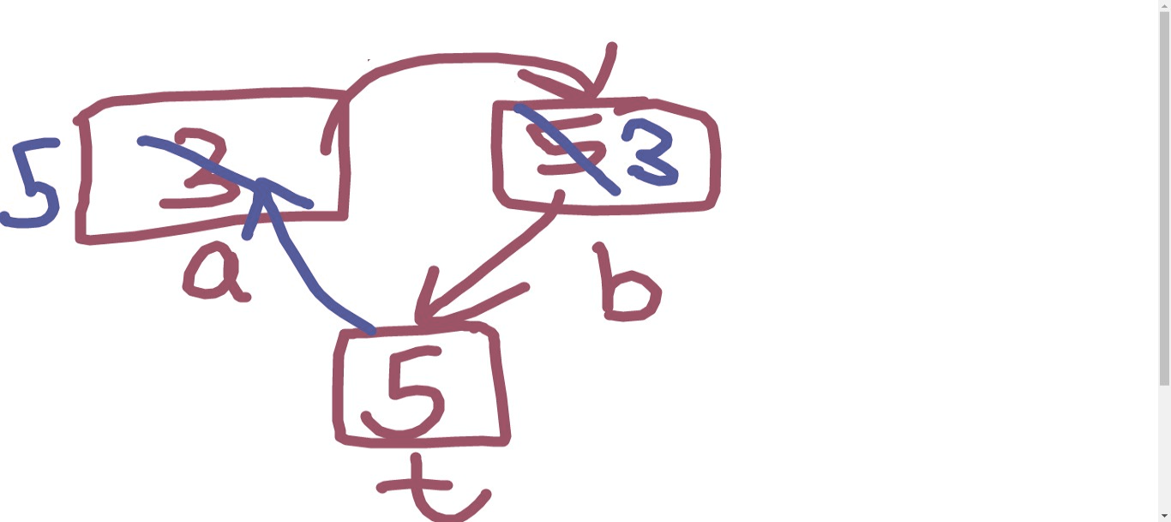

#include <bits/stdc++.h>

using namespace std;

/*

Swap 2 variables.

*/

int main()

{

// = operator moves RHS value to LHS

int a=3;

int b=5;

int t;

cout<<"Earlier values \n";

cout<< a<< " "<< b;

t = b;

b = a;

a = t;

cout<<"Values now \n";

cout<<a<<" "<<b;

return 0;

}

#include <bits/stdc++.h>

using namespace std;

/*

Swap 2 variables without a third new variable.

*/

int main()

{

// = operator moves RHS value to LHS

int a=3;

int b=5;

cout<<a<<" "<<b<<'\n';

a = a + b;

b = a - b;

a = a - b;

cout<<a<<" "<<b<<'\n';

return 0;

}